**TWO-BIT HALF SUBTRACTOR:**

**EXP NO:22**

**AIM:**To design and implement the two-bit half subtractor using a Logisim simulator.

**APPARATUS:** logicism

**PROCEDURE:**

1)      Pick and place the necessary gates.  
2)      Insert 2 inputs into the canvas.  
3)      Connect the inputs to the OR gate, AND gate, and NOT gate.  
4)      Insert 2 outputs into the canvas.  
5)      Make the connections using the connecting wires.   
6)      Verify the truth table.

**TRUTH TABLE:**

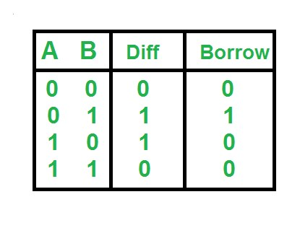

Diff=A'B+AB'  
  
Borrow = A'B

**OUTPUT:**

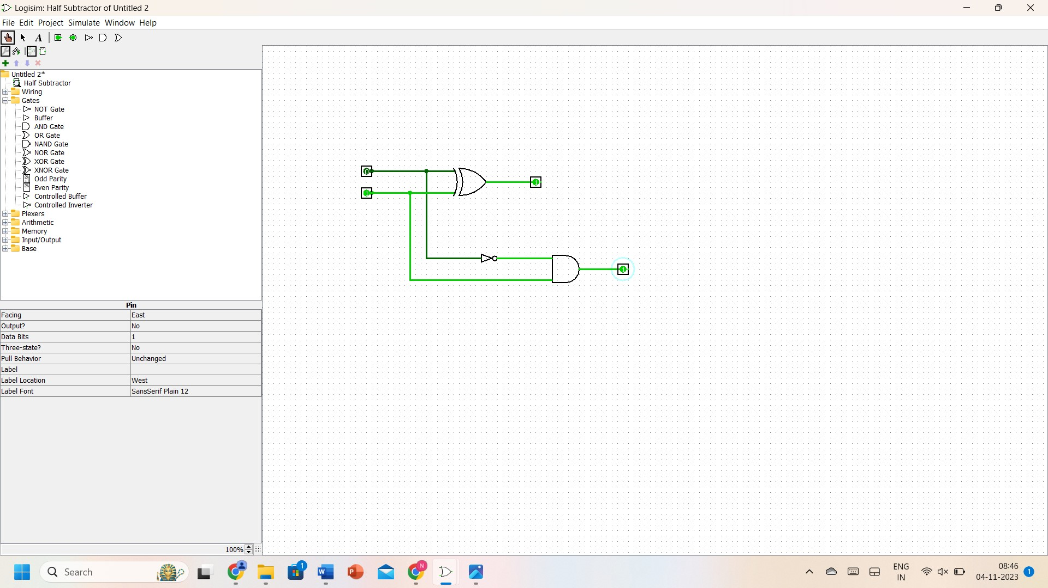

**RESULT:** Thus 2-bit half subtractor has been designed and implemented successfully using the Logisim simulator.